Project Report: ABC Call Volume Trend Analysis

**Project Overview:**

The ABC Call Volume Trend Analysis project aims to analyze inbound call data for ABC Insurance Company to derive insights and propose a manpower plan for effective customer service. With a dataset spanning 23 days, containing various details such as agent information, queue time, call time, call duration, and call status, the project seeks to uncover patterns and trends in call volume, call duration, and agent availability throughout the day. By understanding these patterns, the project aims to optimize manpower allocation to meet customer demand and reduce abandon rates, ultimately improving the overall customer experience.

<https://d.docs.live.net/13793048bb5d8196/Documents/ABC%20call%20analysis/ABC_call_analysis.xlsx>

**Approach:**

1. **Handling missing data:**

* Used pandas and seaborn to visualize null values in each column

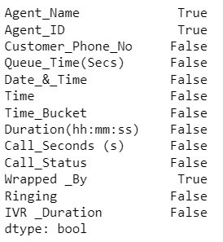

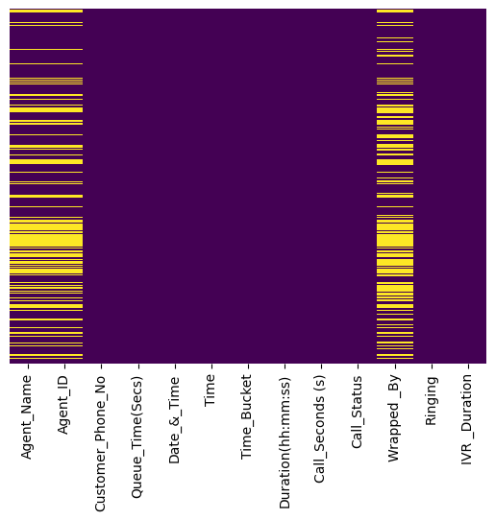

* Handled the missing data using mode function “df=df.fillna(df.mode().iloc[0])”.

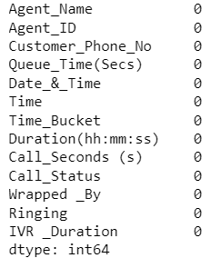

1. Found the correlation and plotted a heatmap for better visualization.

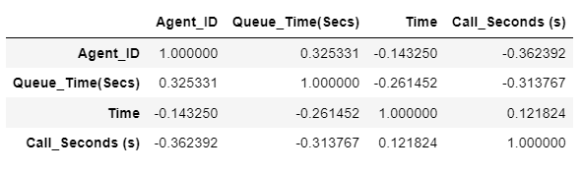

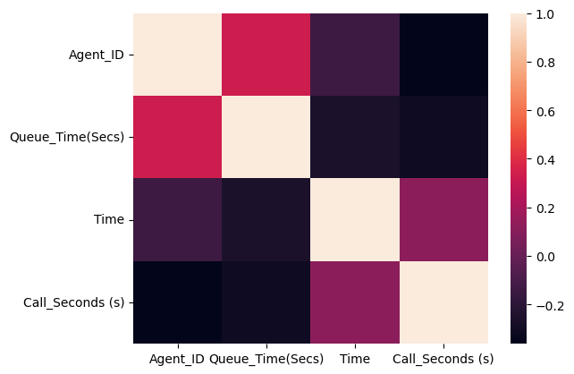

1. Used Box & Whisker plot to check for outliers in every column and detected outliers in Call_seconds column.

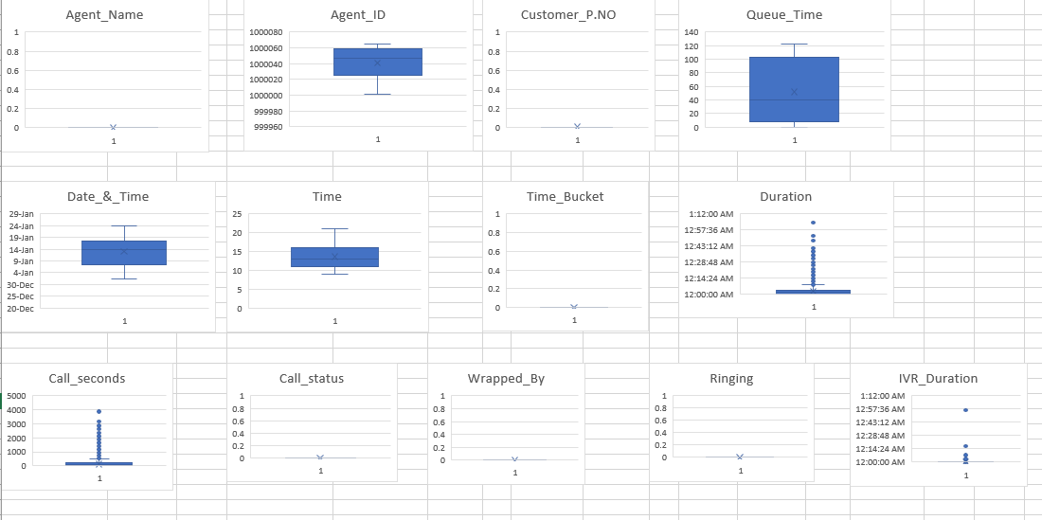

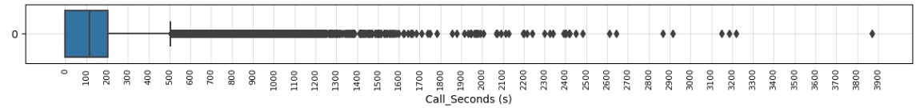

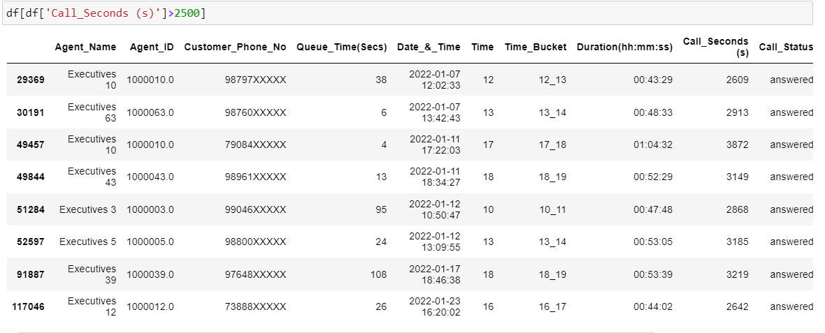

* I assumed the threshold as 2500 and there are only 6 values above that range which do not make a huge reference.

**Data Analytics Tasks:**

1. What is the average duration of calls for each time bucket?

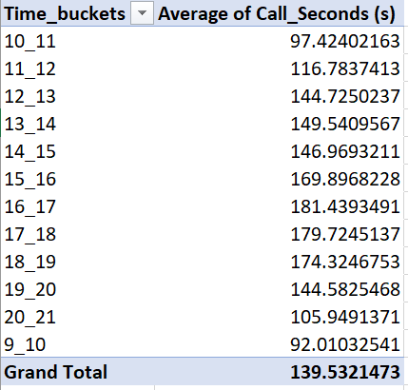

* The overall average call duration is 139.5 where the average call duration peaked in the evening hours around 4pm to 7pm

1. Can you create a chart or graph that shows the number of calls received in each time bucket?

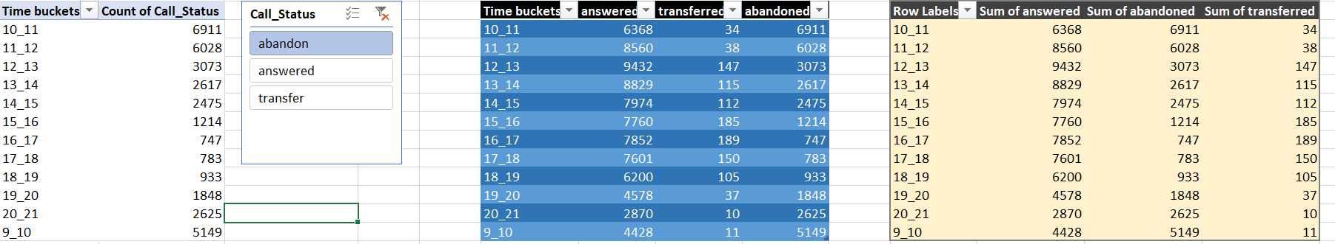

* We can observe that number of calls received increased in the afternoon and number of abandoned calls are high in the fresh hours.

1. Manpower Planning: The current rate of abandoned calls is approximately 30%. Propose a plan for manpower allocation during each time bucket (from 9 am to 9 pm) to reduce the abandon rate to 10%. In other words, you need to calculate the minimum number of agents required in each time bucket to ensure that at least 90 out of 100 calls are answered.

Your Task: What is the minimum number of agents required in each time bucket to reduce the abandon rate to 10%?

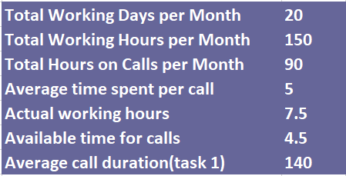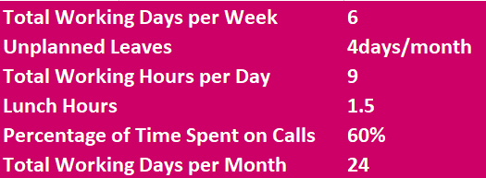

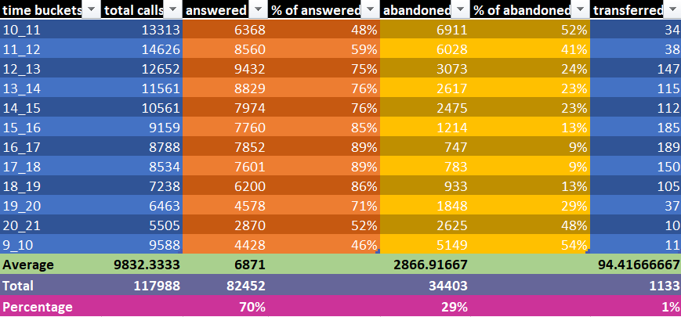

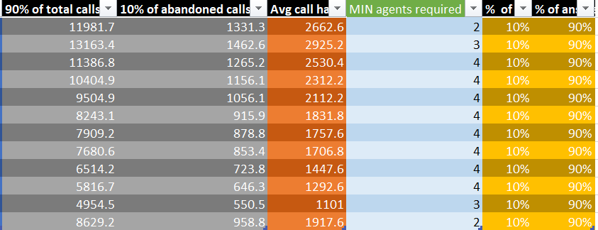

* Time Buckets: This column represents different time intervals or time buckets during the day when calls are received. For example, "10_11" represents the time interval from 10:00 AM to 11:00 AM.
* Total Calls: Total number of incoming calls received during the respective time bucket.
* Answered: The number of calls that were successfully answered by agents during the respective time bucket.
* % of Answered: The percentage of calls answered out of the total calls received in the respective time bucket. This indicates the efficiency of agents in handling incoming calls.
* Abandoned: The number of calls that were abandoned by callers before reaching an agent during the respective time bucket.
* % of Abandoned: The percentage of calls abandoned out of the total calls received in the respective time bucket. A higher percentage indicates a higher abandonment rate, which can negatively impact customer satisfaction.
* Transferred: The number of calls that were transferred to another department or agent during the respective time bucket.
* 90% of Total Calls: 90% of the total calls received in the respective time bucket. This is used as a target for the number of calls that should be answered by agents.
* 10% of Abandoned Calls: 10% of the abandoned calls during the respective time bucket. This represents the maximum allowable number of abandoned calls to maintain a 10% abandonment rate.
* Avg Call Handling Capacity: The average call handling capacity per agent during the respective time bucket. It is calculated by dividing the total calls by the total time an agent required to handle them.
* Min Agents Required: The minimum number of agents required to handle the incoming calls in order to achieve a 10% abandonment rate.
* % of Abandoned in Total: The percentage of abandoned calls out of the total calls received throughout the day. This provides an overall view of the abandonment rate across all time buckets.
* % of Answered Calls: The percentage of answered calls out of the total calls received throughout the day. This indicates the overall efficiency of the call handling process.

1. Night Shift Manpower Planning: Customers also call ABC Insurance Company at night but don't get an answer because there are no agents available. This creates a poor customer experience. Assume that for every 100 calls that customers make between 9 am and 9 pm, they also make 30 calls at night between 9 pm and 9 am. The distribution of these 30 calls is as follows:

Your Task: Propose a manpower plan for each time bucket throughout the day, keeping the maximum abandon rate at 10%.

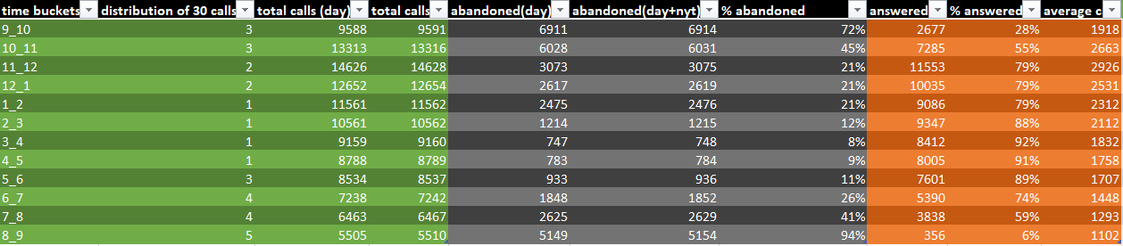

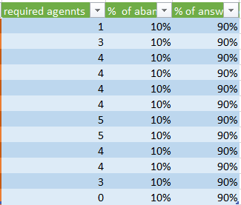

**Tech Stack Used**

* Jupyter Notebook 6.5.2 — Interactive platform to write and execute codes in various programming languages (in this case Python).
* Microsoft Excel 2019 — A spreadsheet editor software used mainly by professionals to enter data in table format, perform computations, plot graphs etc.

**Insights:**

* **Peak Call Times:** The analysis reveals peak call times during the day, such as between 11 AM and 2 PM, where the call volume is relatively higher compared to other time buckets. This insight can help in resource allocation, ensuring that sufficient agents are available during peak hours to handle incoming calls promptly.
* **Efficiency of Call Handling:** The percentage of answered calls varies across different time buckets, indicating fluctuations in agent efficiency throughout the day. Understanding these variations can aid in optimizing agent schedules and training programs to improve call handling efficiency during peak and off-peak hours.
* **Abandonment Rate:** The analysis highlights the abandonment rate of calls, with percentages ranging from 9% to 54% across different time buckets. High abandonment rates can negatively impact customer satisfaction and indicate potential issues in call handling processes or agent availability. By identifying time buckets with high abandonment rates, targeted strategies can be implemented to reduce wait times and improve call resolution rates.
* **Manpower Requirements:** The calculation of minimum agents required in each time bucket provides valuable insights into resource allocation and staffing needs. By ensuring that an adequate number of agents are available during peak call times, businesses can minimize wait times, reduce abandonment rates, and enhance overall customer experience.
* **Night Shift Manpower Planning:** The analysis of night shift calls highlights the importance of providing customer support outside regular business hours. By understanding customer call patterns during the night, businesses can implement manpower plans to address customer inquiries and ensure a positive customer experience round-the-clock.

**Conclusion**

This project, helped me in understanding the importance of Data Analytics in Customer Experience Analysis as it provides valuable insights which helps in making Data-Driven Decisions.

In this project I was able to get insights like call abandon rates, distribution of call duration, number of calls, agents, how to create a manpower plan so as to decrease abandon calls etc. I also got experience in Data Preprocessing like Data Cleaning, handling Outliers, Feature Engineering etc. in this project. I can now communicate the insights to relevant stakeholders as per the requirements.